About App –

Single app, where the user can view the segregated news (business, technology etc)

Can naviagate to the Trending News

Integrated with the Youtube API – where the user can view the live news in the app(can handle all the youtube controllers in the app itself)

LandingPage:

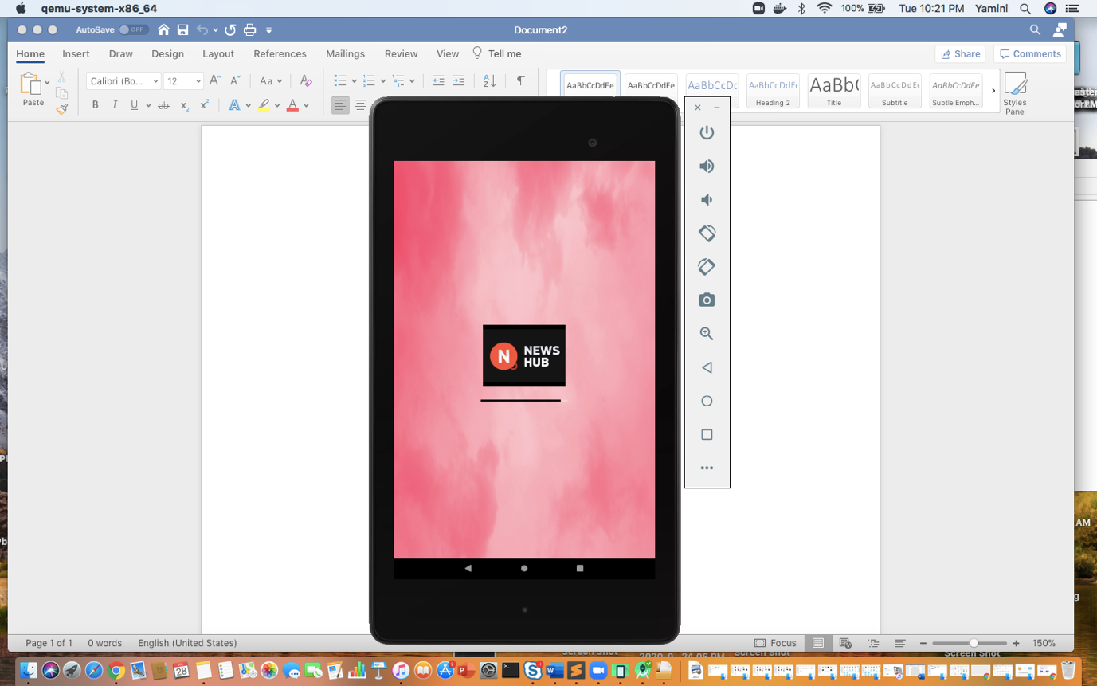

MainPage

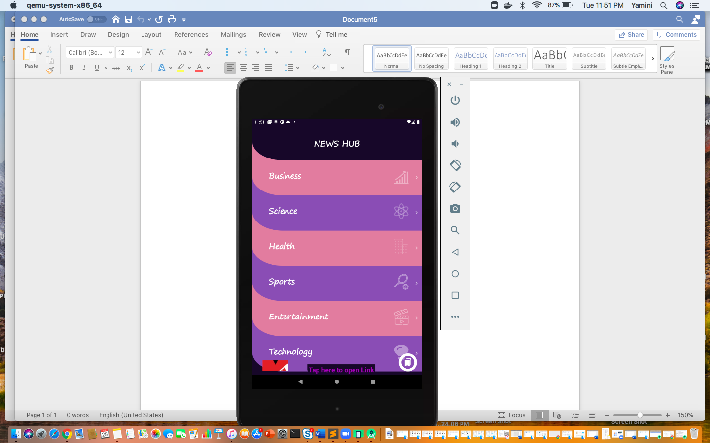

OnSwipe

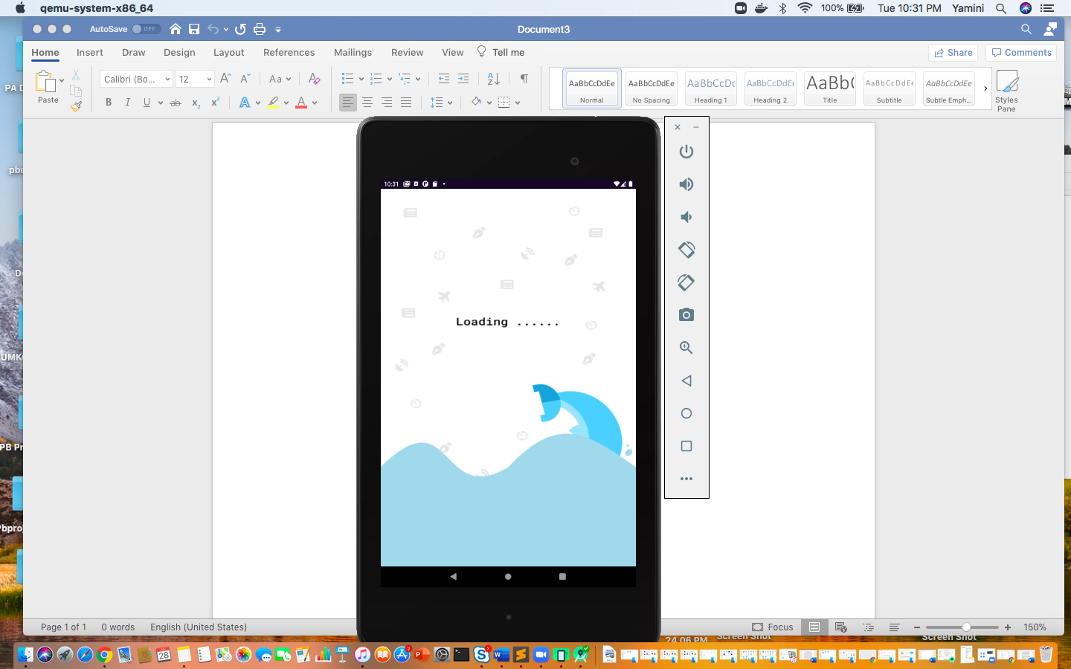

Business NEWS Swipe

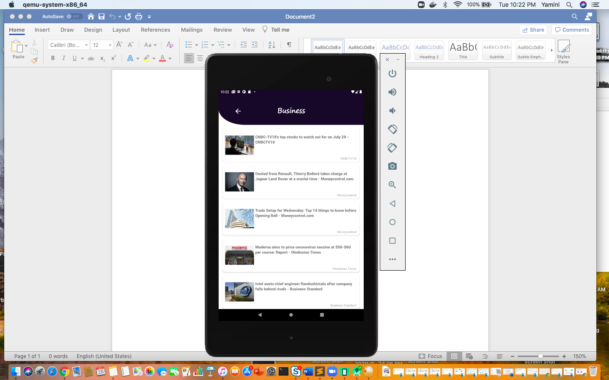

BookMarked

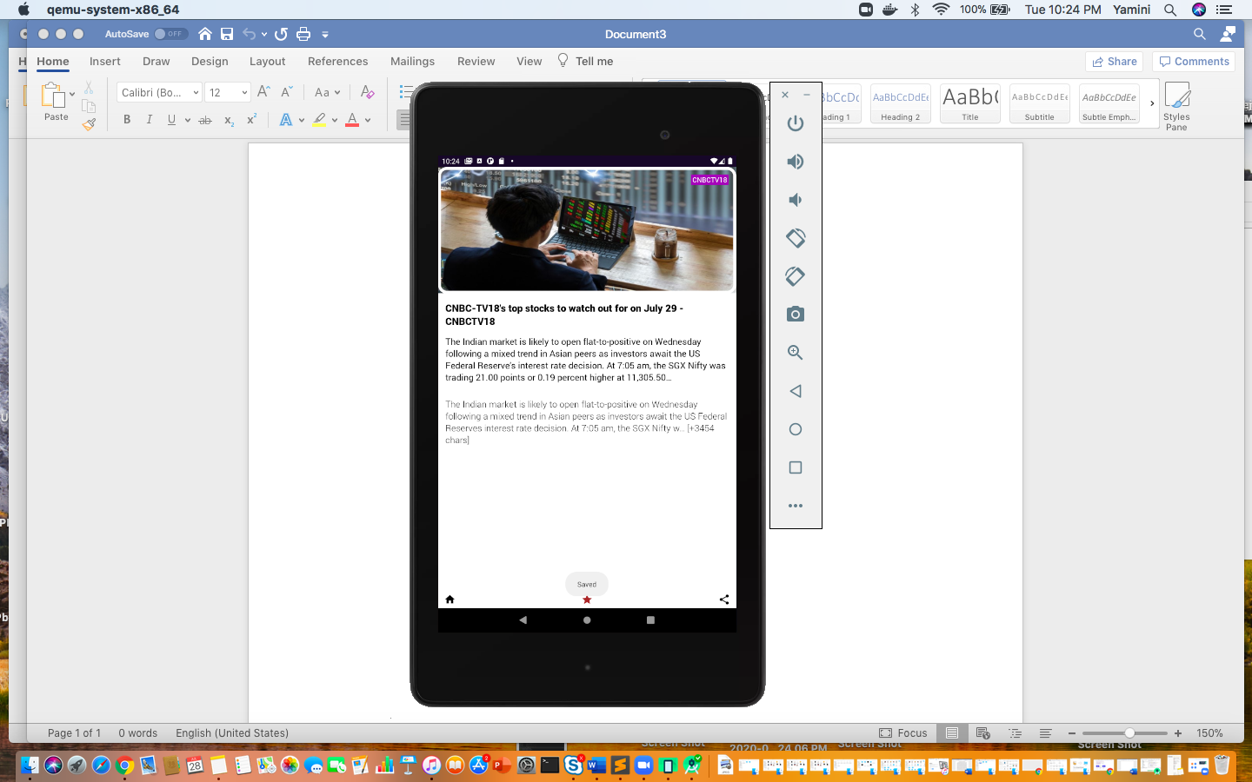

Email

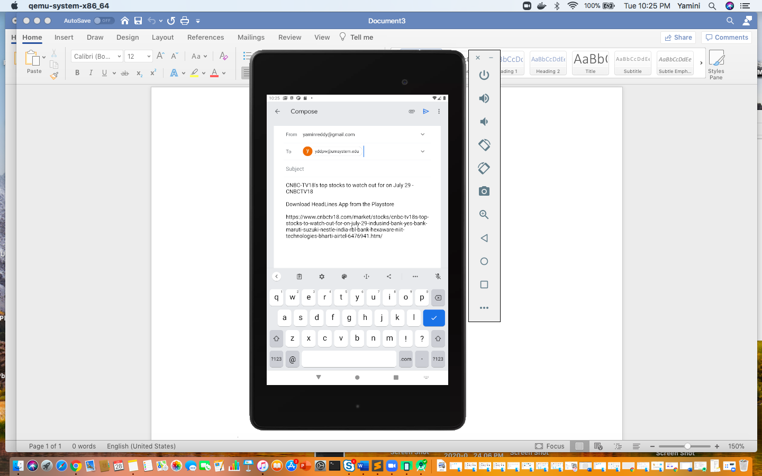

BookMarks Screen

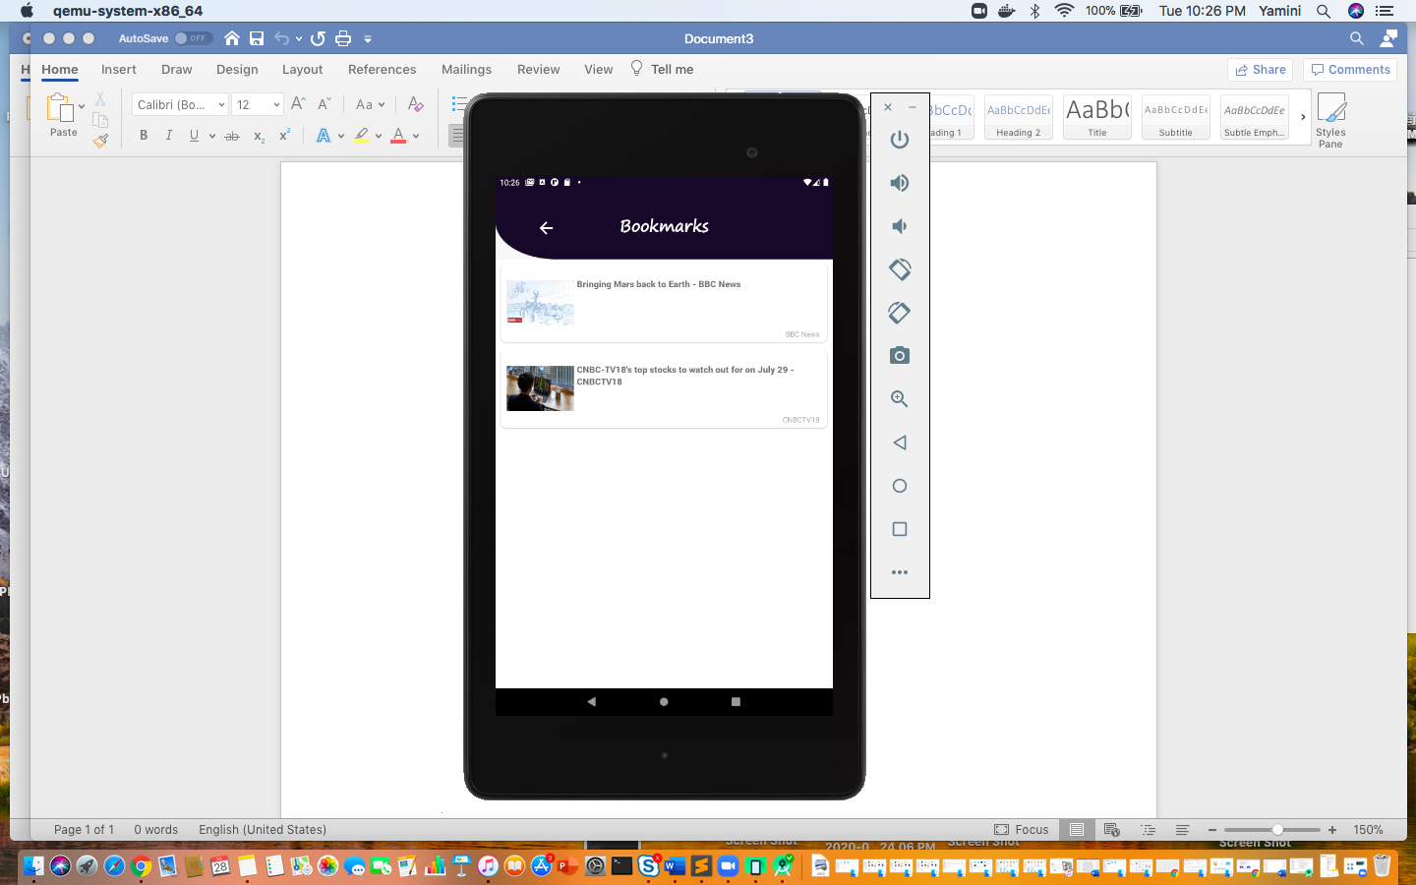

Youtube Page: When the user clicks on the youtube icon, it will navigate to this page and will play the video.\*I will modify the Youtube video to live news youtube channel – that way it would be appropriate)

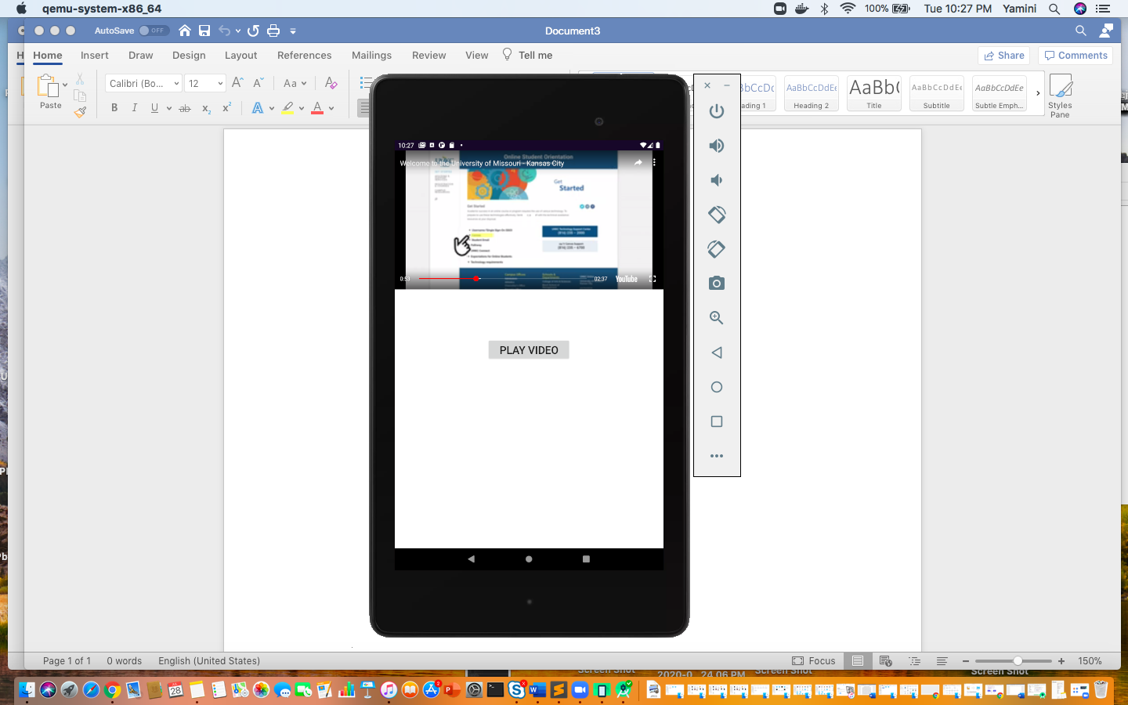

Link – TrendingNews Navigation: When user clicks on the link, it will navigate to the trending news link

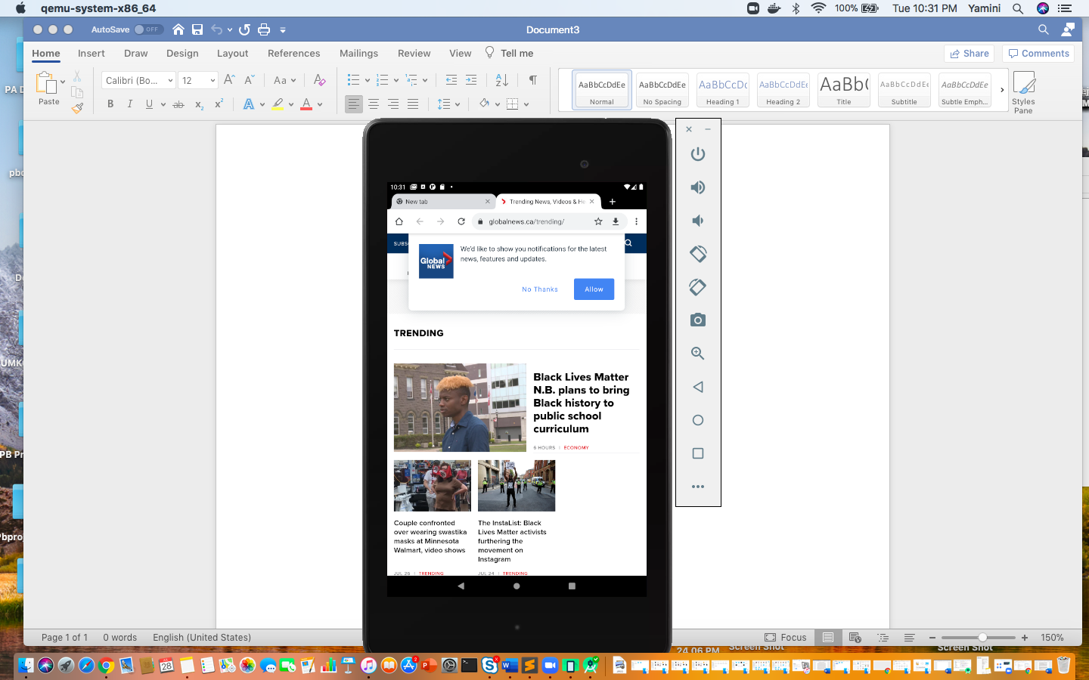

NewsAPI Keys – Created account and generated the API keys

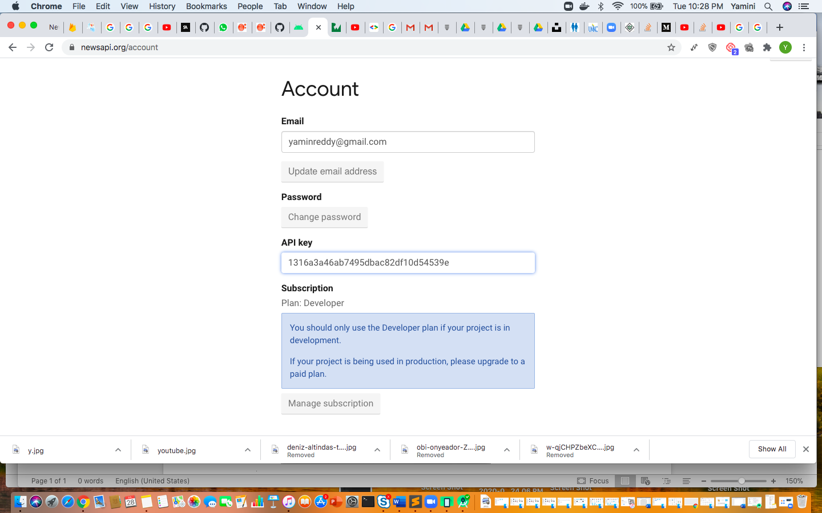

YoutubeAPI Keys – Created the account and generated the API keys. For Android Need SHA1 Keys for Android Apps.

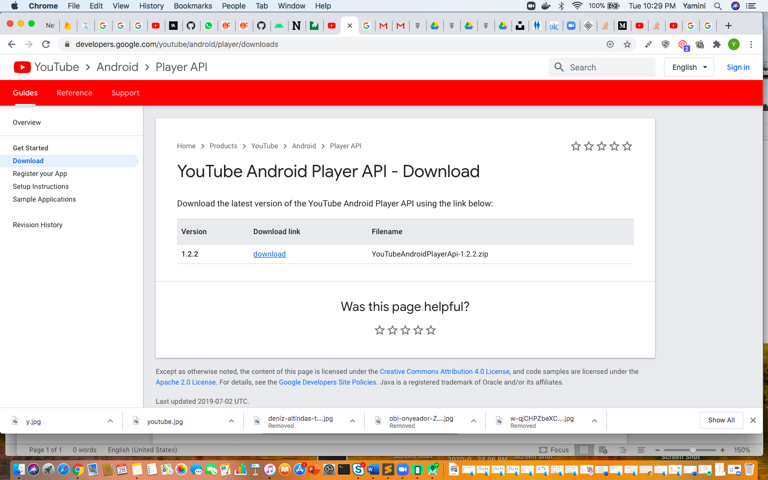

GoogleConsole

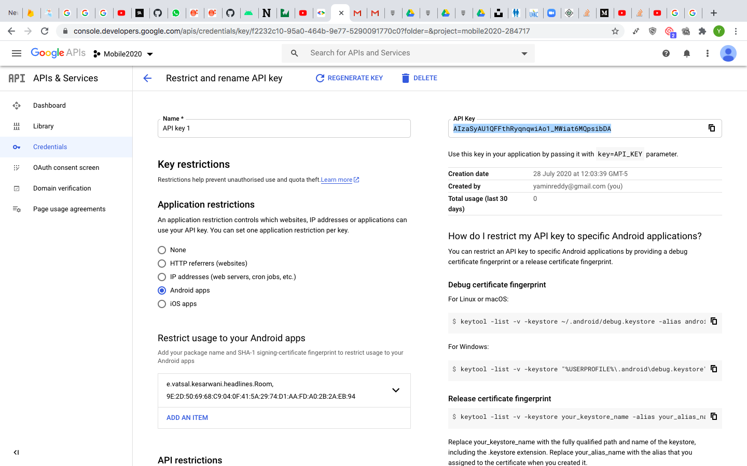

AndroidManifestXML

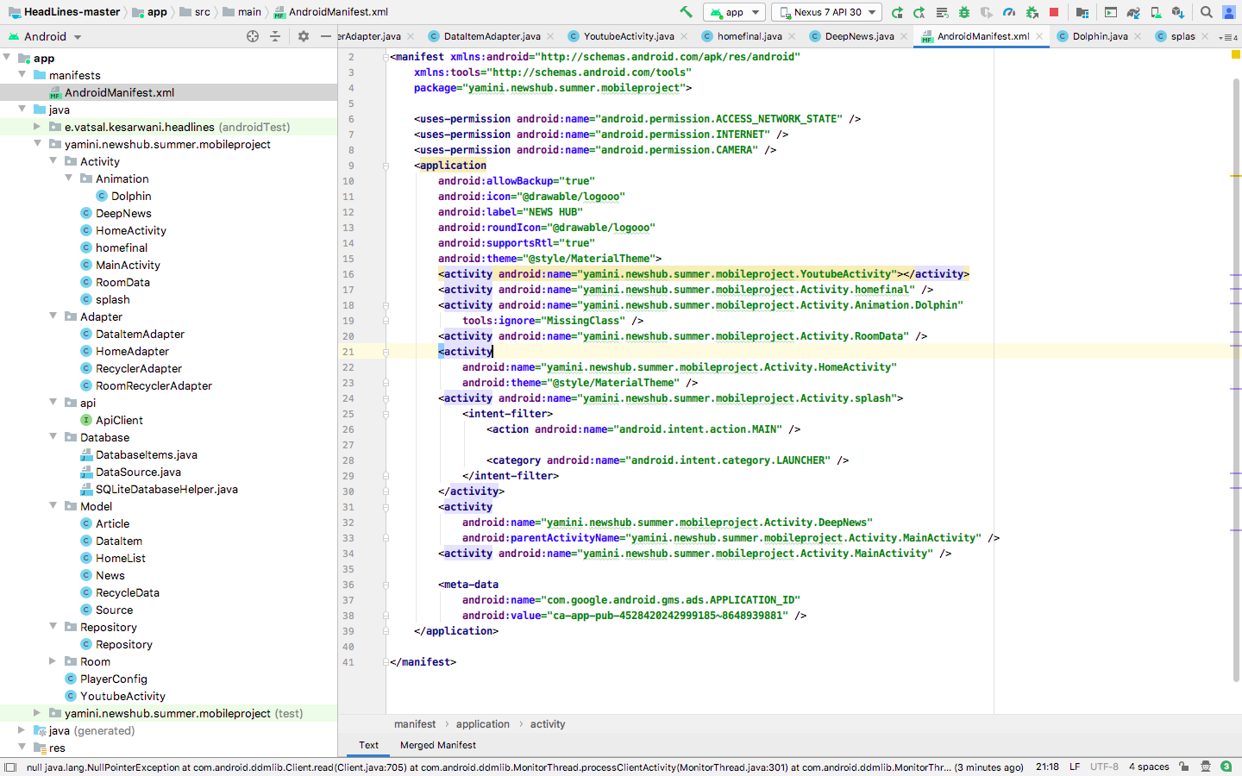

XML Files :

LandingPageXML:

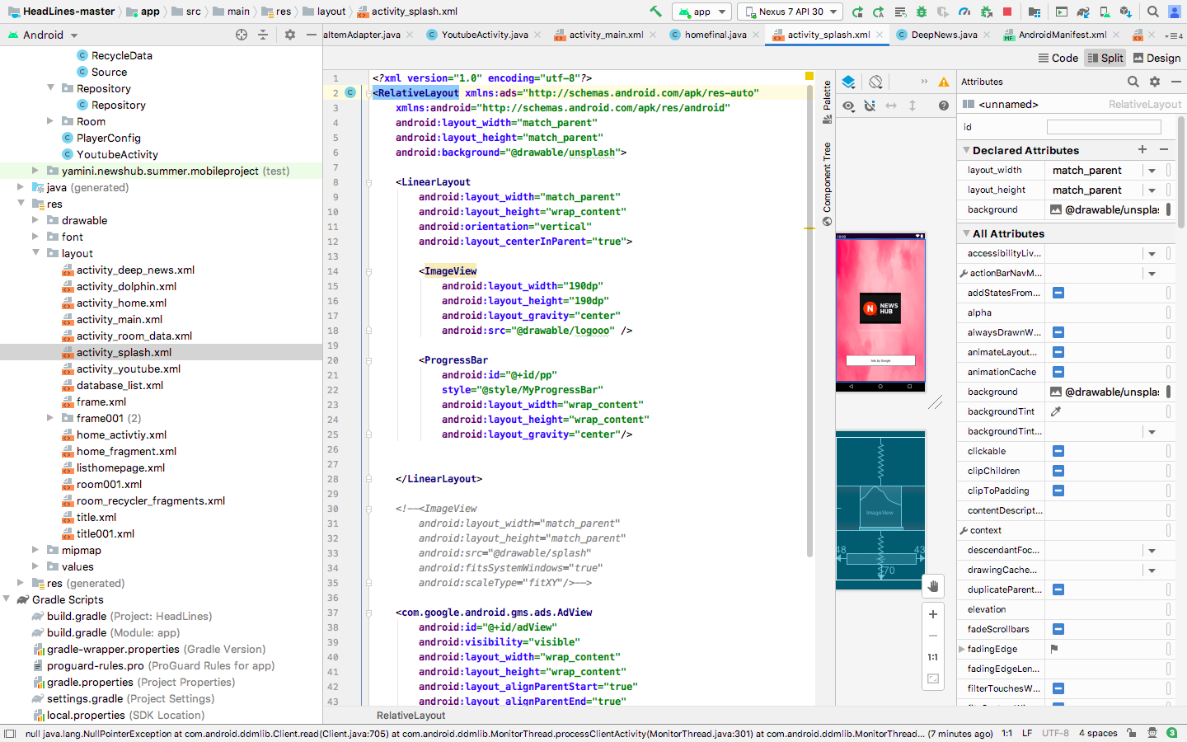

HomeActivityXML

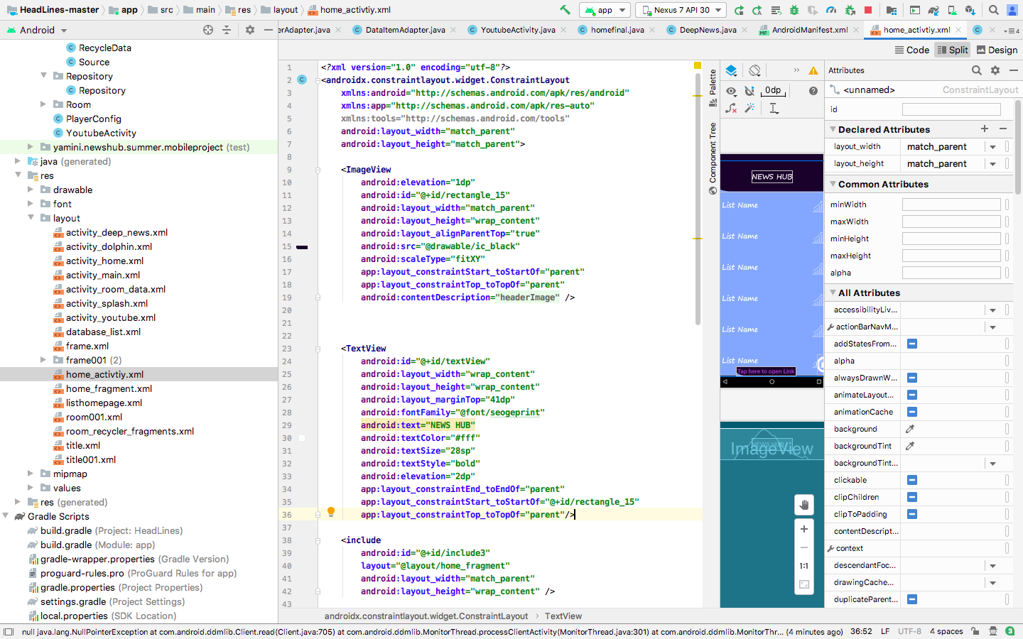

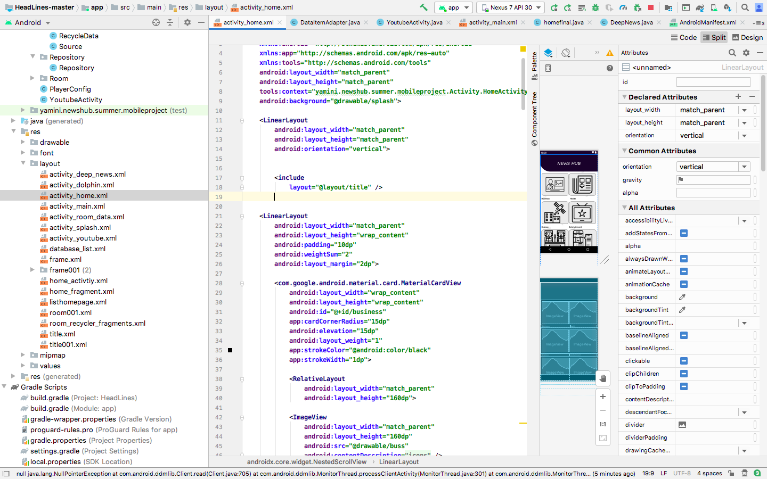

MainActivityXML

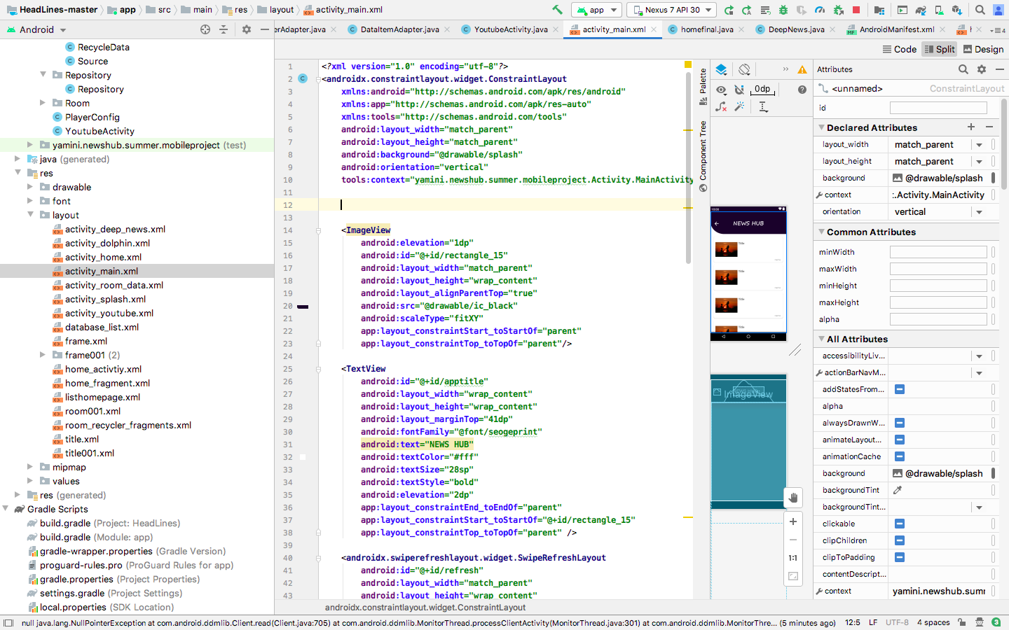

YoutubeActivityXML

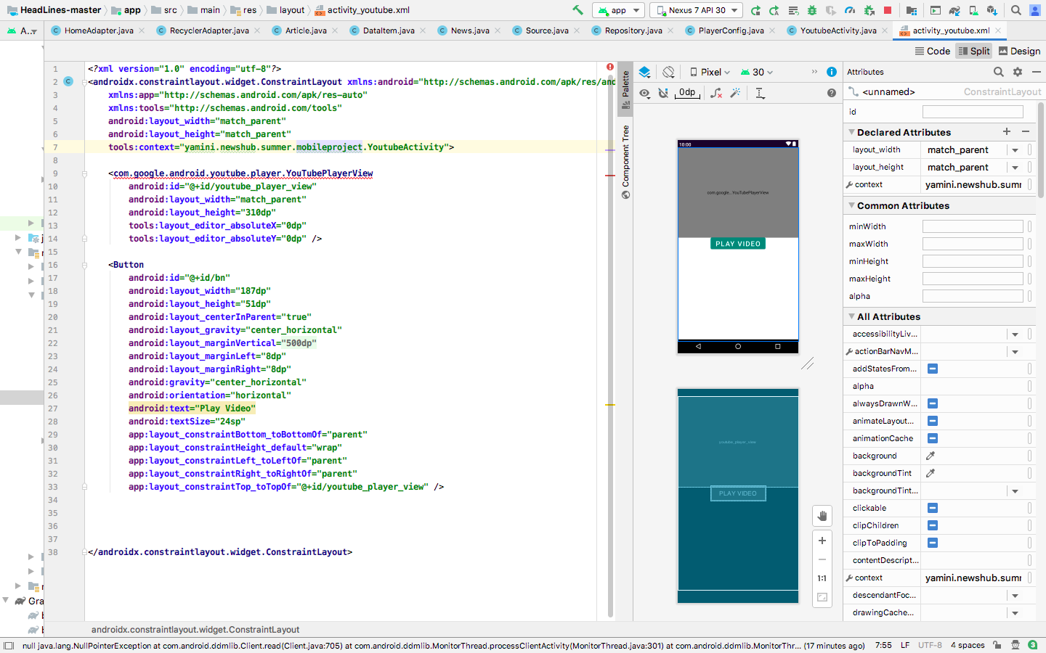

JAVA Files:

LandingPage-Javafile

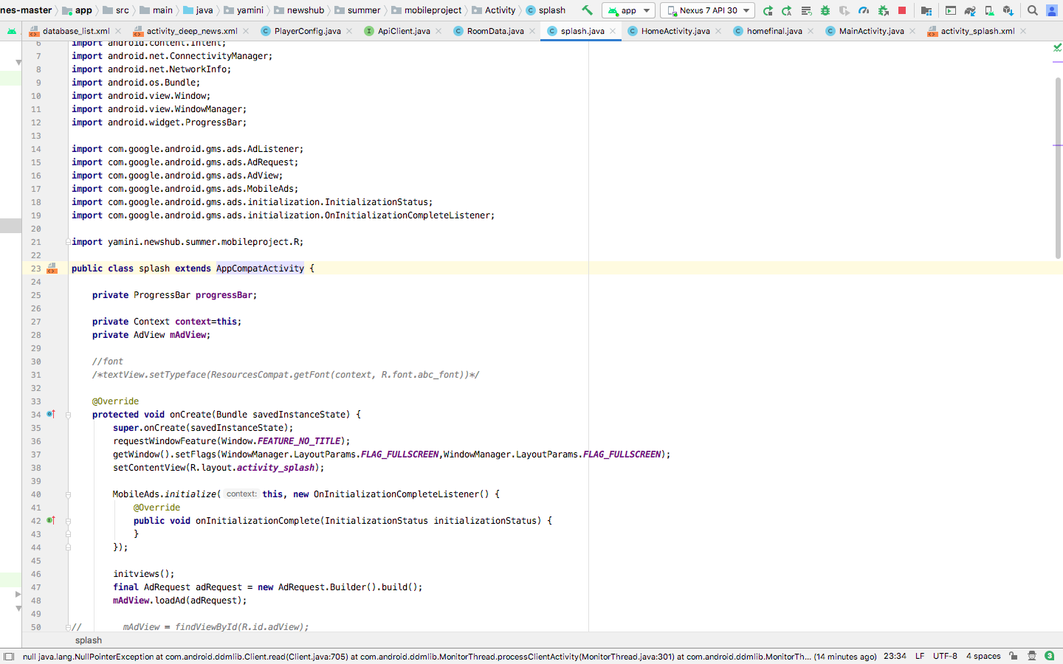

HomePage-JavaFile

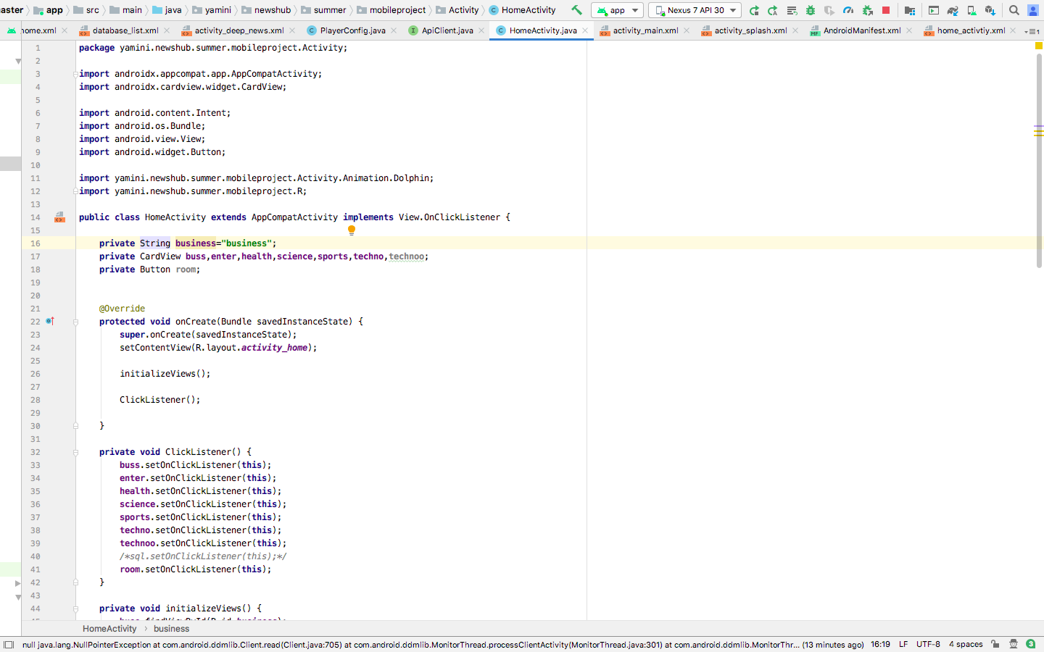

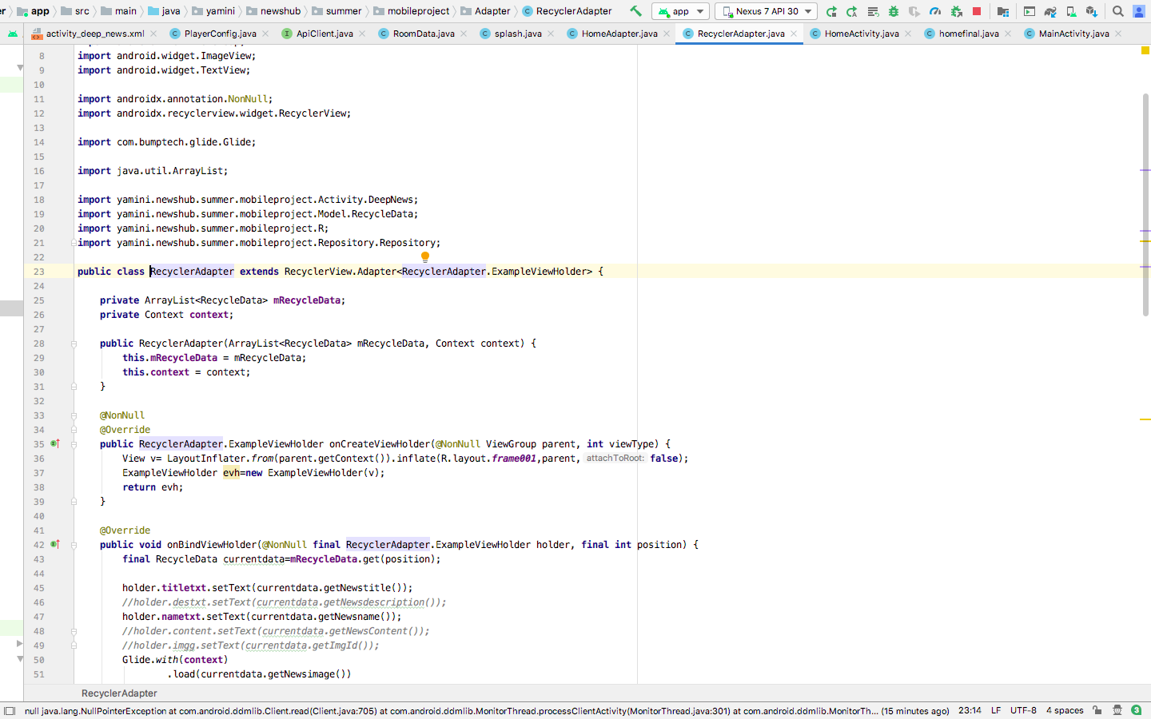

YoutubeActivity- JAVA File

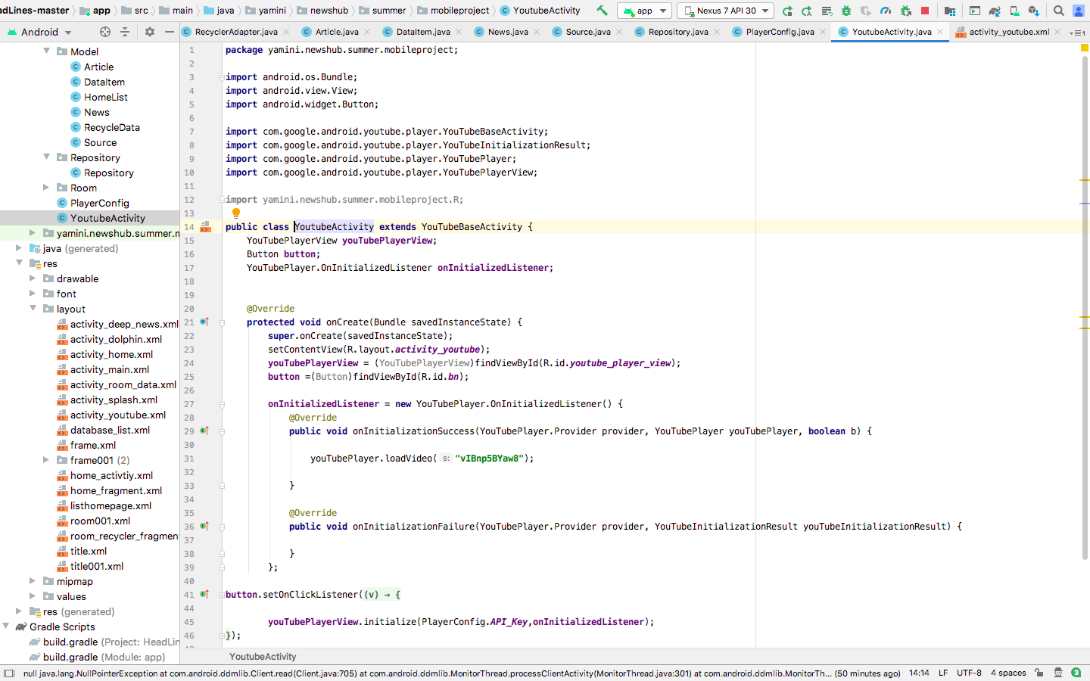

Youtube API – JAVA File

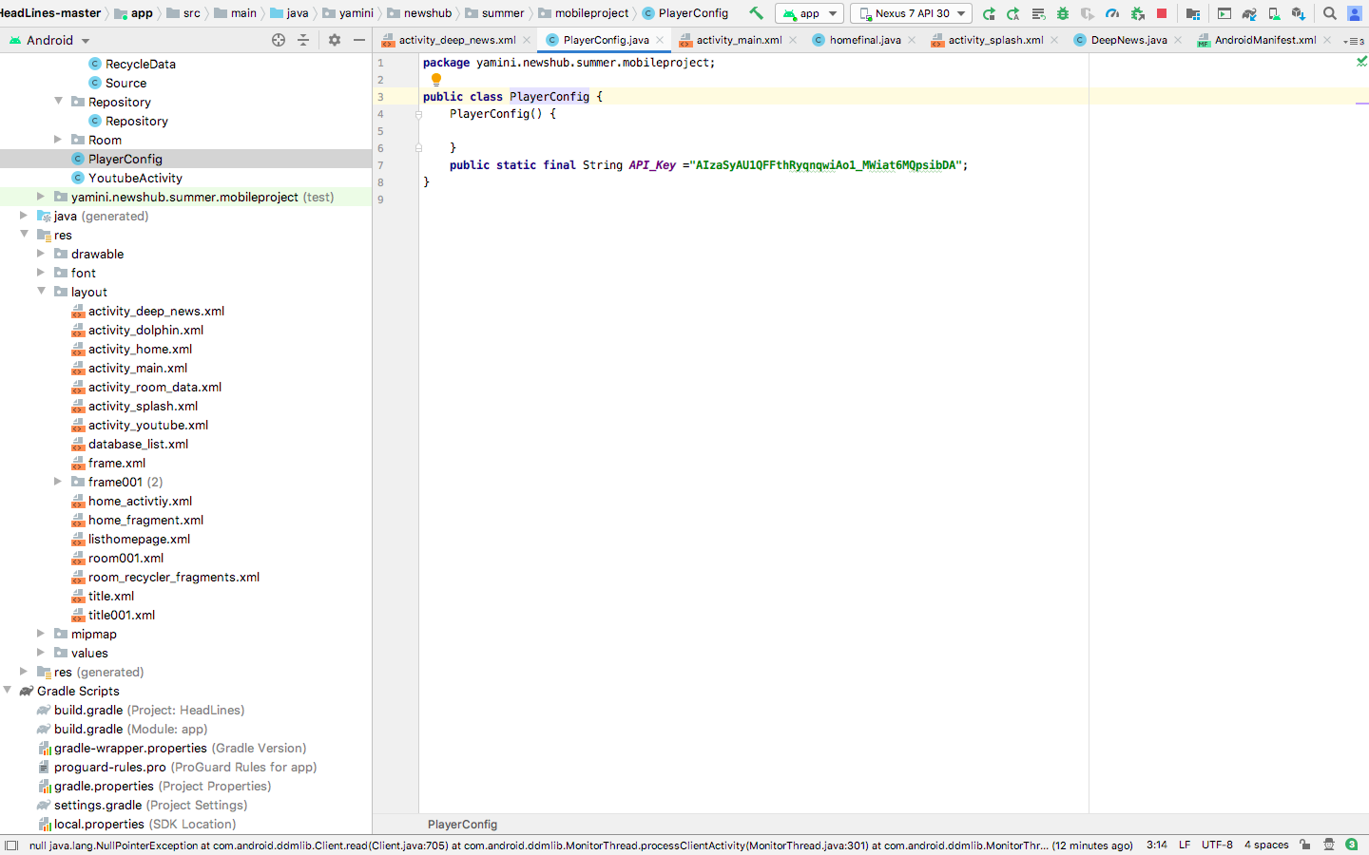

NewsAPI – JAVA File

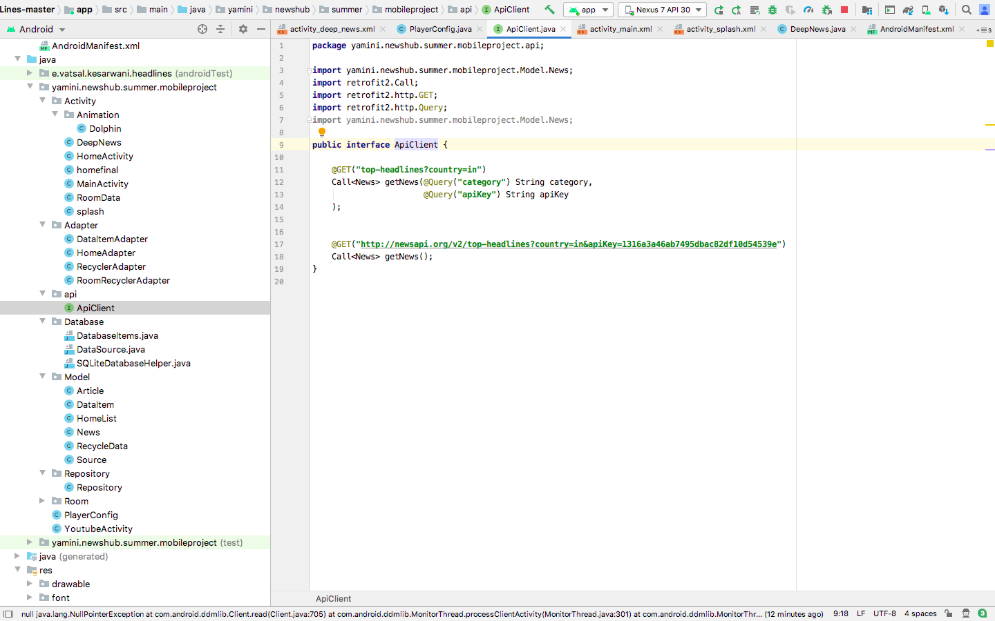

DB – JAVA Files

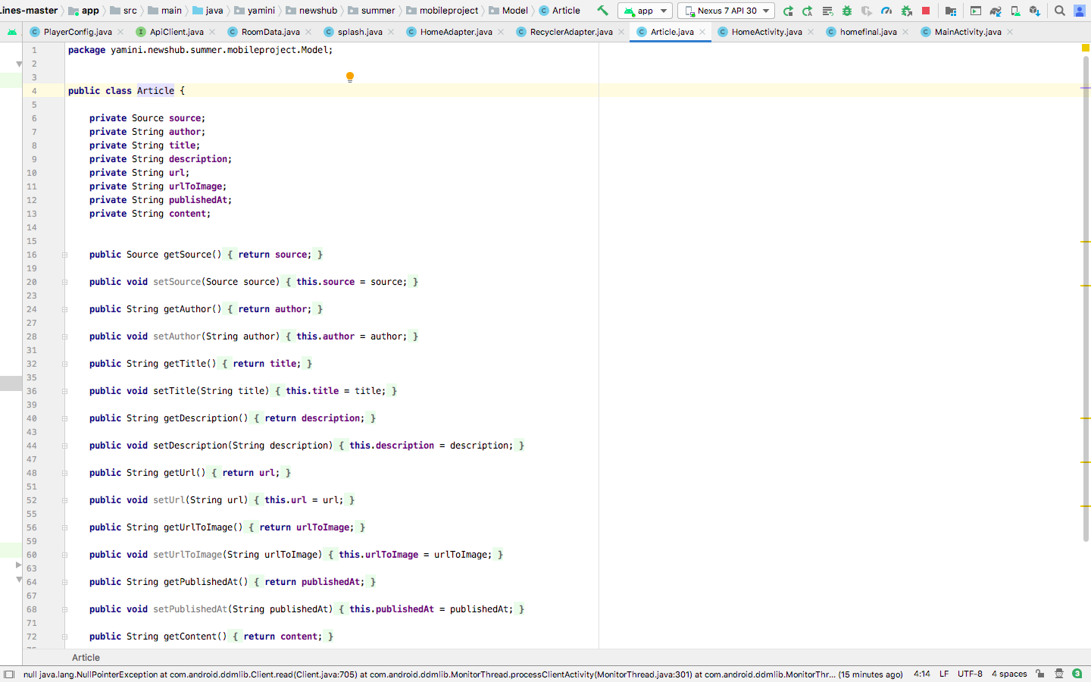

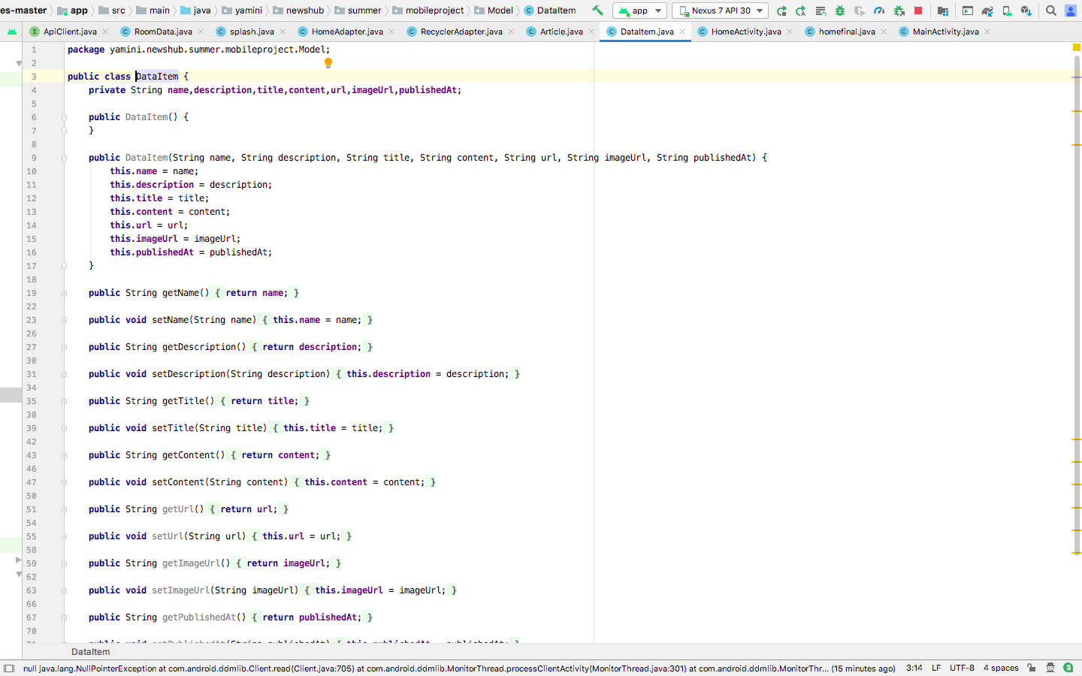

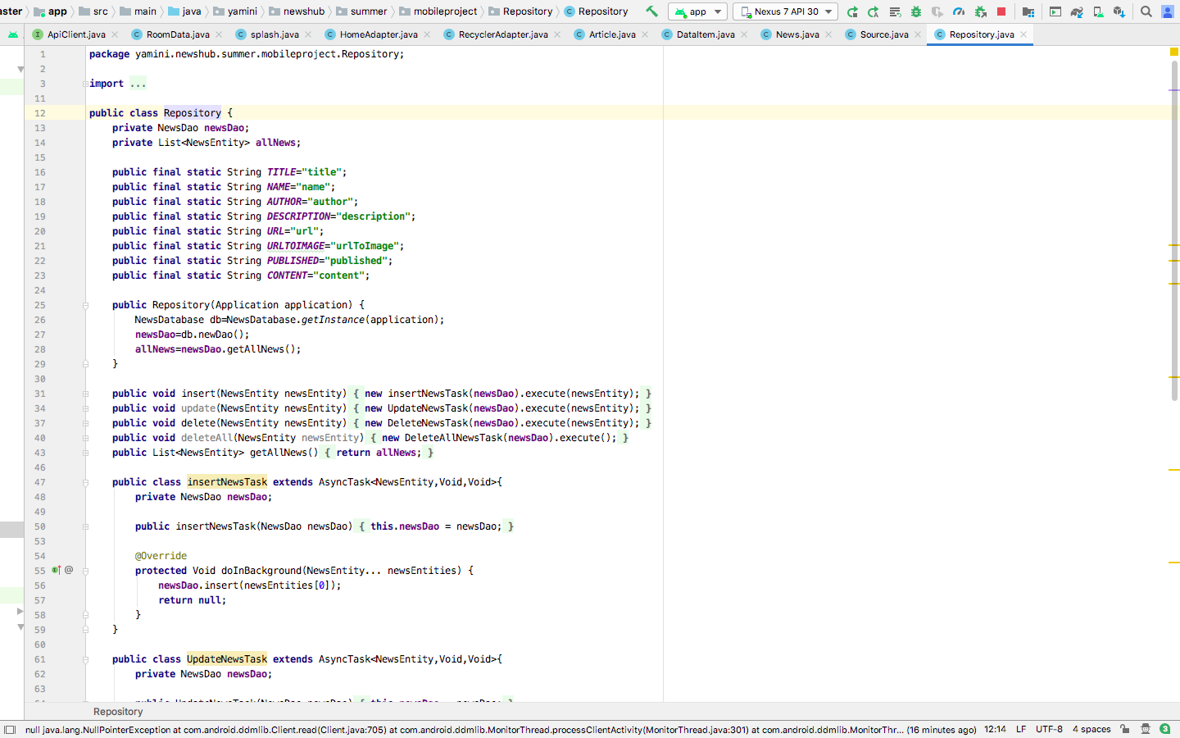

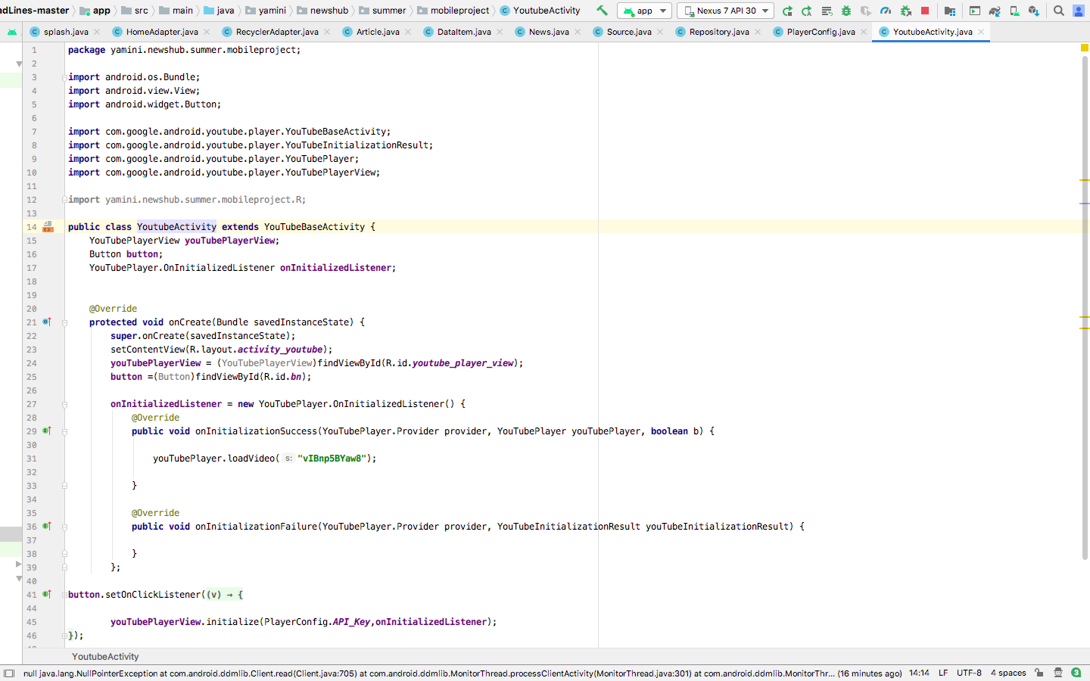

Emulator – AVD Manager

